Quiz 1 ***(CSE331L.7 – Asif Ahmed Neloy_Summer’20)***

Department of Electrical and Computer Engineering

School of Engineering and Physical Sciences

North South University, Bashundhara, Dhaka-1229, Bangladesh

*Time 20 minutes, Marks 20 (You need to answer all questions).*

***Name – Jahin Mahbub***

***ID - 1531552042***

1. **Why it is never a good idea to store any data in the segment registers? [5]**

**Ans: We should never use the segment registers as data registers to hold arbitrary values.They should only contain segment addresses.**

1. **Write a program in Assembly language that will add 4 integer number (1,2,2,1) using only AX register and Store the result in the AX register.**

**Ans:**

**MOV AX, 01**

**MOV BX, 02**

**ADD AX,BX,BX,AX**

**ret**

**output:**

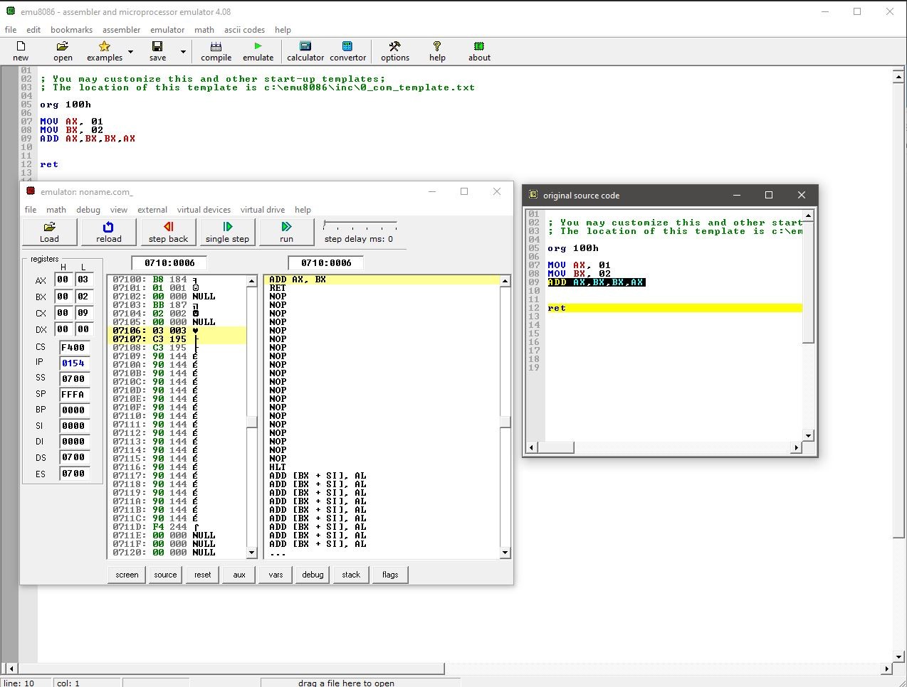

**End**